MONITORING ADVERSE DRUG REACTIONS
The medicines used for SMC implementation are effective and well tolerated but can be associated with adverse events that can be mild, moderate or severe. In general, adverse events are events temporally associated with exposure to a medicine; thus, an adverse event is not necessarily causally associated with the medicine (see definitions below).

An ADVERSE EVENT (AE) is any unfavourable or unintended symptom or disease (including laboratory findings temporally associated with use of a medicinal product), which may or may not be considered to be related to exposure to medicinal product.
A SERIOUS ADVERSE EVENT (SAE) is any untoward medical occurrence in response to a medicine that at any dose:
- is life-threatening;
- requires or prolongs hospitalization;
- results in disability or incapacity;
- results in congenital abnormality or birth defect;
- results in death; or
- may require intervention to prevent one of the outcomes listed above.

All adverse events should be reported to the national pharmacovigilance (PV) centre to ensure safe implementation of SMC and build trust in the communities.

In many locations, routine pharmacovigilance systems will have to be strengthened to ensure effective reporting of medicine-related adverse events during implementation of SMC. Key features of a functional pharmacovigilance include:

- Functional technical safety advisory committee
- AE spontaneous reporting tools and processes in place for collection, recording and analysis of reports
- PV included in SMC guidelines, plans of action and CHW training
- District investigation teams (to promptly investigate serious adverse events)
- Crisis communication plan
- Capacity for causality assessment
- Reporting to WHO via data management system that can transfer data to the WHO global database of Individual Case Safety Reports, VigiBase, maintained by the WHO Collaborating Center for International Drug Monitoring (Uppsala Safety Monitoring Center, Sweden) – see https://www.who-umc.org/vigibase/vigibase/

Clear guidelines must be in place for effective monitoring of drug safety at all levels, including:

- Definition of the roles and responsibilities of staff;
- Standard definitions of ‘adverse event’ and ‘serious adverse event’ for use by all staff;
- Use of standard forms for recording, reporting and investigating serious adverse events;
- Guidelines for recording, reporting and investigating serious adverse events;
- Criteria for assessing the association between the event and SMC medicines;
- Documentation of action taken (including referral)
- Clear indications on patients that require immediate referral due to SAE:
- Use of a national pharmacovigilance database to record all serious adverse events.

Health personnel and, community health workers should be trained to identify and report adverse events.

See SMC Trainer guide and resource tool kit-Nigeria Malaria Consortium, Module 5 (Page 52) smctrainerguideandresourcetoolkit_nigeria.pdf (malariaconsortium.org)
Job aid: Guide to severe side effects of SMC medicines: Example from Nigeria (Milligan P, Scott S, NDiaye JL, Merle C (2018)) Monitoring the safety of Seasonal Malaria Chemoprevention during large scale implementation through the ACCESS-SMC project (extended version of report).42pp. LSHTM.
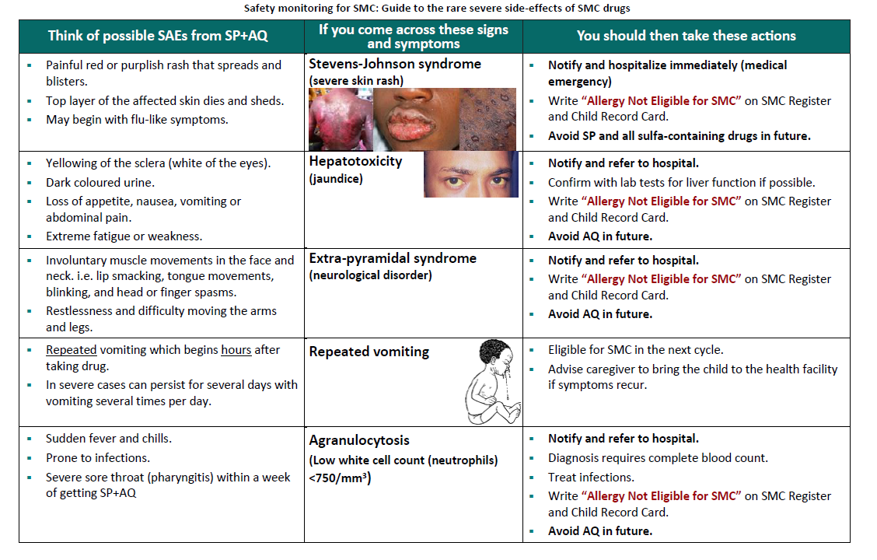
The commonest mild adverse events associated with AQ intake are vomiting (for more than 2 hours), abdominal pain, fever, diarrhoea, itching, headaches, weakness for more than 2 days and rash. Mild adverse events associated with SP involve the skin and mucous membranes.
In rare cases, AQ can cause neurological disorder (extra-pyramidal syndrome) and liver injury (hepatotoxicity, or jaundice) may occur. Serious skin reactions (cutaneous toxicity, Steven–Johnson syndrome) are very rare but can occur after SP administration. Very rarely, any medicine can cause anaphylactic shock, a severe allergic reaction that occurs quickly. Steven-Johnson and anaphylactic shock are medical emergencies which require immediate hospitalisation. At all levels, including at hospital referral the health workers should receive refresher training on how to diagnose and manage these conditions, prior to the start of the SMC campaign.
Agranulocytosis, aplastic anaemia and severe, even fatal, hepatotoxicity are rare serious adverse events associated with weekly prophylactic use of AQ; such events can be confirmed only with laboratory tests; they have not been reported with use of AQ as part of SMC.

The caregivers should be sensitized and informed about the possibility of these adverse events and the need to refer the child promptly should they occur.

Recording and reporting adverse events

If community health workers identify a serious adverse event, they should report it to nurses at the health centre, who will complete the Adverse events reporting form (see below) and send it to the district medical office for appropriate action.

Guidance should be provided on identifying and reporting medicine-related adverse events to ensure that the minimum information is available for assessment of any reported event. Information could include reporter identification and contacts, patient name, age, sex, weight, brief description of the event, including seriousness, date of onset after medicine intake and outcome of the event, SMC medicines and concomitant medicines given, including dosage regimen, dates of onset and termination, batch number and expiry date.

Example of the adverse event reporting form adapted from SMC program in Senegal.

Patient |  | Reporter
Name: ……………………………………………. |  | Name: …………………………………………..…
Date of birth:.…./….../….. or age: …….. |  | Medical doctor: / / Pharmacist: / /  Dentist: / / Nurse: / / Midwife: / /  Other / / (specify): ……………………………  Telephone: ………………………....  Email: …………………………….……  Health Facility ………………………..  Other contact info ……………………  Signature of Reporter:  ………………………………………......  Date of report :.…./….../…..
Sex: F / / M / /
Weight: ………………..
Address: ………………………………………......
….……………………………………………….……

Telephone …………………………………….……

Medical history/associated factors

………………………………………………………

………………………………………………………

Medicine |  | Event
SMC medicine given: ………………………..  No. of tablets on Day 1 …. date: …./…./…  No. of tablets on Day 2 …. date: …./…./…  No. of tablets on Day 3 …. date: …./…./…  Repeat SMC dose / /  No. of tablets on repeat dose ….  date: …./…./…  Concomitant medicines: Y / / N / /  Concomitant medicine 1 …………………….  No. of tablets on Day 1 …. date: …./…./…  No. of tablets on Day 2 …. date: …./…./…  No. of tablets on Day 3 …. date: …./…./…  Concomitant medicine 2 …………………….  No. of tablets on Day 1 …. date: …./…./…  No. of tablets on Day 2 …. date: …./…./…  No. of tablets on Day 3 …. date: …./…./… | Description of event:  ………………………………………………………  ………………………………………………………  ………………………………………………………  Start date: ………/……./……….  End date: ………/……../……….  Outcome of event:  Resolved / /  Recovered with minor sequelae / /  Recovered with major sequelae / / Ongoing/Continuing treatment / /  Condition worsening / /  Death / /  Unknown / /  Action taken:  Dose modification / /  Treatment interruption / /  Referral / /  Hospitalization / /  Other: / / (specify): …………………  ………………………………………….

In reporting, it is important to distinguish between

- CHW observations during administration vs adverse events (AEs)
- Solicited caregiver reports when asked about previous AEs
- AEs detected by caregivers that lead to child attending health facility
The NMCP should ensure availability of reporting forms (or electronic reporting) at all health facilities and job aids with pictures/flyers with information about adverse events should be distributed to the community health workers and nurses at health facilities.
The lack of appreciation of the importance of PV by health workers, the difficulty of reporting, complexity of the reporting forms, lack of supervision can lead to underreporting of such events. Sometimes health workers may assume that the event is not related to SMC medicines. However, staff responsible for reporting adverse events should be encouraged to report any such manifestation. Refresher training, training of supervisors and regular discussions with personnel involved in reporting such events is recommended to minimize the risk for underreporting.
Once a serious adverse event has been identified and the patient referred with a referral form, prompt action must be taken by the health facility personnel to minimize the risk for the child´s health and ensure a positive outcome. For some adverse reactions that are clearly drug-related and are life-threatening (e.g., severe skin reactions, anaphylactic reactions), the SMC programme should ensure that cost of care is not a barrier to prompt treatment.
Serious adverse events can cause negative perceptions in the community, undermine confidence in the medicines and the programs delivering them and jeopardize the success of SMC. Crisis may occur when unwanted serious adverse events are rightly or wrongly connected with SMC campaigns. These may have a "real" basis arising from drug reactions or errors in drug administration or may have no foundation in reality and be triggered entirely by mistaken rumours.
Therefore, any such event must be documented whether or not it is related to SMC medicines. Adverse events should be investigated, and if appropriate, mitigating measures then recommended to minimise risks of future events. Besides ensuring patient safety, effective PV also protects/strengthens a programme such as SMC, and it helps in responding to rumours originating in the community about drug safety. Whether a rumour builds into a crisis depends on the nature of the rumour, how fast it spreads and whether prompt and effective action is taken to address it. Therefore, it is important to ensure that a Rumour management system (RMS) is put in place to identify, track, understand and address rumours and to monitor how well the system is working to combat misinformation and disinformation.
To avoid distrust and negative perception an effective RMS should be prepared in advance of SMC deployment and include clear communication and crisis communication plans. An effective RMS is required to explain the risks and benefits of the intervention and any issue that might affect community acceptance of SMC. Crisis communication in the context of a mass drug distributions follows the same steps as any other planning process, but because of the urgency of the situation, compressed time scales apply and is important to be able to implement the plan quickly. The 5 main phases for setting up an RMS are 1) Early planning, 2) Listening and logging rumours, 3) Verifying and understanding information, 4) Putting a rumour management plan into action, and 5) Monitoring the rumour management plan. Throughout the whole process all stakeholders should be involved as part of a broader communication and crisis plan. The four basic elements of a crisis communication plan are: 1) overarching objectives; 2) = target audience; 3) key messages and 4) channels of communication.

Preparations should include:
  - setting lines of communication via trusted channels (e.g., community and religious leaders, CHW associations, trusted journalists and other influential people).
  - creating multiple public forums to ask questions or raise concerns (social media platform, telephone hotlines, local field workers).
Communication must be clear, transparent, timely and empathetic. Information should be accessible, and when it is not possible to share specific information about an ongoing investigation, information about the ongoing and expected processes should be shared. Partnering with the media can help to disseminate information quickly and multiple channels are needed to get key messages to the target communities.

